ITA0305- Mobile Computing
LAB EXPERIMENT
Name: G.Ganesh
Reg NO:192373008

23) Design a power-saving mode for the app.

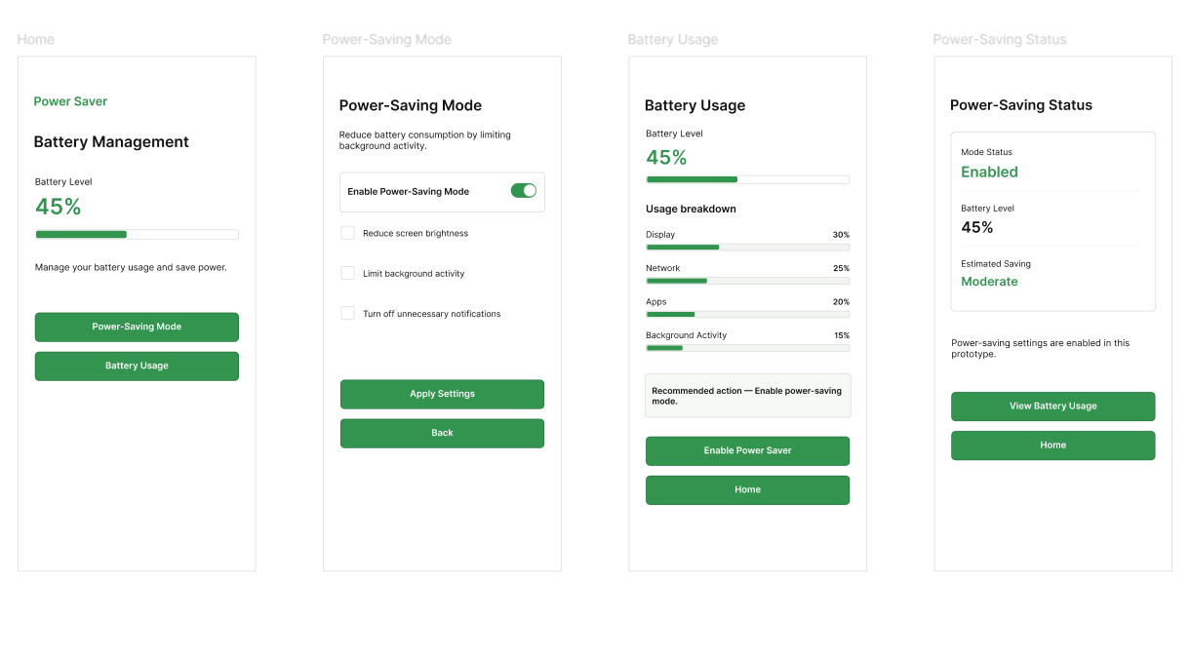
https://www.figma.com/design/rgHx5ubdXFxsfxxh1aTlTs/program23?node-id=0-1&p=f&t=icxoqml74Tc26G1M-0

